Code changes

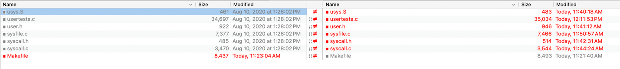

usys.S



usertests.c

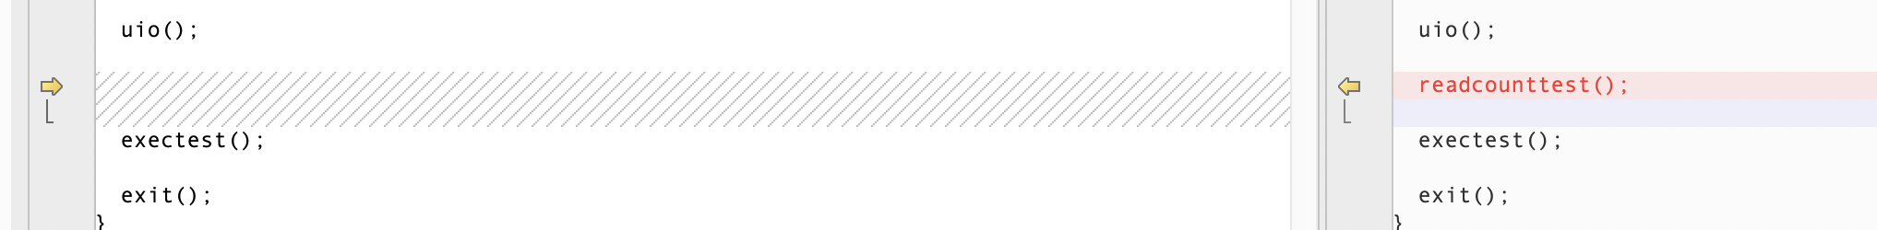

user.h



sysfile.c

syscall.h



syscall.c

Makefile